SCMUN
St. Catherine’s Model United Nations Conference

DELEGATE MANUAL

A Complete Guide to Rules of Procedure, Resolution Writing, and Committee Participation

Written by:

Cecilia Passa
6th SCMUN Secretary General

TABLE OF CONTENTS
Chapter 1 Introduction to Model United Nations
1.1 What is Model United Nations?
1.2 The Purpose of SCMUN
Chapter 2 Parliamentary Conduct and Expectations
2.1 Dress Code
2.2 Use of Technology and Devices
2.3 General Conduct Rules
Chapter 3 Rules of Procedure
3.1 Quorum
3.2 Roll Call
3.3 Debate Modes: Open and Closed
3.4 Points
3.5 Motions
3.6 Yielding the Floor
3.7 Voting Procedure
3.8 Funding
3.9 Points and Motions: Reference Table
Chapter 4 Amendments
4.1 Amendment of the First Degree
4.2 Amendment of the Second Degree
4.3 Amendment Procedure: Flow Diagram
Chapter 5 Resolutions and Lobbying
5.1 What is a Resolution?
5.2 How to Write a Resolution
5.3 Resolution Formatting Rules
5.4 Approved Phrase Lists
5.5 Sample Resolution
5.6 Lobbying Procedure
5.7 Plagiarism Policy
Chapter 6 Conference Preparation
6.1 Background Research
6.2 Policy Statements and Opening Speeches
Chapter 7 Speeches and Points of Information
7.1 Speech Template
7.2 Critical Questions for Speech Writing
7.3 Points of Information: Categories and Examples
Appendix Note-Passing Guidelines

Chapter 1 INTRODUCTION TO MODEL UNITED NATIONS

1.1 What is Model United Nations?
Model United Nations is an academic simulation of the deliberative bodies that constitute the real United Nations (UN). Participants represent one of the UN's 193 Member States (or 195, including formally recognised observer states), working to negotiate, deliberate, and produce formal written resolutions that address some of the most complex challenges facing the international community today.
Conference participation demands sustained intellectual engagement across several disciplines. Before arriving, delegates must research their assigned country's foreign policy, historical relationships, and national stance on the committee's designated topics. During the conference, they must engage in formal diplomatic discourse, persuasive public speaking, and collaborative resolution drafting, while adhering to a strict procedural framework based on the actual Rules of Procedure of the United Nations.
The UN was established in 1945, in the aftermath of the most destructive conflict in human history. Its founding Charter articulated four core purposes: to preserve international peace and security; to cultivate cooperative relations among sovereign states; to facilitate international collaboration on economic, social, cultural, and humanitarian challenges; and to serve as a focal point for harmonising the collective actions of nations. SCMUN is conducted in precisely this spirit.

1.2 The Purpose of SCMUN
St Catherine's Model United Nations (SCMUN) is a conference that aims to provide participants of all experience levels with a demanding, rigorous, and educationally meaningful simulation of UN procedure. SCMUN operates under the THIMUN (The Hague International Model United Nations) Rules of Procedure. Delegates are expected to represent their assigned country's positions with conviction, to engage with the substance of every debate, and to conduct themselves throughout with decorum and professionalism.

Chapter 2 PARLIAMENTARY CONDUCT AND EXPECTATIONS

2.1 Dress Code
SCMUN is a simulation of the United Nations, and delegates are expected to dress in a manner consistent with the seriousness of that institution. Formal business attire is required at all committee sessions, ceremonies, plenary sessions, and throughout all conference hours.
The following standards apply:
- Gentlemen must wear a formal business suit, or a blazer or jacket with formal trousers, a dress shirt, and a tie. Jackets must be worn at all times when a delegate is at the podium speaking.
- Ladies must be dressed with equivalent formal standards, in a business suit, smart dress, or formal separates.
- In order to maintain the diplomatic neutrality of the simulation and to avoid causing offence, national dress, military uniforms, political insignia, armbands, and team accessories are strictly prohibited.
- The following items are also prohibited: sports or casual footwear, denim of any colour, short skirts, clothing with low necklines, stiletto heels, sports hats, sunglasses, and any clothing or accessory that draws undue personal attention.
Dress code violations will not be addressed publicly.

2.2 Use of Technology and Devices
Delegates should note the following regulations regarding the use of electronic devices within committee:
- Mobile phones must be kept on silent throughout all committee sessions. They may not be used for personal communications, social media, or any purpose unrelated to the committee's business.
- Laptops and tablets are permitted during sessions for the purposes of accessing submitted resolutions, researching matters directly relevant to the debate, and drafting or reviewing amendments.
- The use of any device for entertainment, social networking, or personal communication during a committee session is strictly out of order and will be addressed by the Chairs.
- The Chairs may suspend the use of devices at any point if it is determined to be causing a disruption to proceedings. Devices can also be confiscated by the Student Officers of that Committee, or a Secretariat Member.

2.3 General Conduct Rules
- Food is not permitted in the committee room at any time. Water is the only permitted beverage.
- All delegates must open their speech by addressing the Chair and the full house: 'Honourable Chairs, fellow delegates…'
- Delegates speak on behalf of a sovereign state, not as individuals. The personal pronoun 'I' must not be used; delegates must refer to themselves as 'the delegation of [country]', 'this delegation', or 'we'.
- Delegates must stand throughout their speech and must remain standing while a Point of Information directed to them is being read and while they are delivering their response.
- Abusive, insulting or unparliamentary language of any kind is strictly prohibited.
- Countries at lower stages of economic development must be referred to as 'Less Economically Developed Countries (LEDCs)'. Countries at higher stages must be referred to as 'More Economically Developed Countries (MEDCs)'. The terms 'Third World Countries', 'Developing Countries', and 'First World Countries' are not in order.
- Delegates must not raise their placards until the Chair has explicitly invited them to do so.
- All notes passed during committee sessions must be written in English and must contain content relevant to the proceedings. Bullying, harassment, or offensive content in notes can lead to note passing being suspended.

Chapter 3 RULES OF PROCEDURE

The procedural rules set out in this chapter govern all formal committee sessions at SCMUN. Their purpose is to ensure that debate is conducted fairly, transparently, and above all, democratically. Delegates participating in the Security Council, the Historical Security Council or the International Court of Justice should also refer to the manual regarding their specific Rules of Procedure.

3.1 Quorum
Quorum is the minimum level of attendance required for committee proceedings to be considered formally valid.
Two thresholds apply:
- To open a session and allow debate to proceed, at least one-third (1/3) of the delegations assigned to the committee must be present.
- For any decision to carry formal validity (whether the adoption of a resolution, the passing of an amendment, or any other formal vote) a majority of the committee's full membership (more than 50%) must be present at the moment the vote is taken. The Chairs are responsible for monitoring this continuously via the roll call list and committee tracker.
If the number of delegates present falls below the majority threshold immediately before a vote, that vote cannot validly proceed. The Chairs will adjourn or suspend the session until sufficient attendance is restored. The Responsible Secretariat Member of that committee will also be notified.

3.2 Roll Call
A formal roll call must be conducted at the opening of each day's session and upon the committee's return from break.
- The Chair calls each delegation by name in alphabetical order.
- A delegate may respond either 'Present' or 'Present and Voting'. A delegate responding 'Present and Voting' will not be able to abstain during a vote on a resolution or amendment. A delegate responding 'Present' retains that right.
- All records are entered on the official Tally Sheet, which is maintained by one Chair and shared with the conference Secretariat.
- Delegates who arrive after their name has been called are required to send a note to the Chairs immediately. Their attendance will be formally noted only upon receipt of this notification.

3.3 Debate Modes: Open and Closed
Two modes of debate are employed at SCMUN. Open Debate is the main mode used when the committee is deliberating on a resolution as a whole. Any delegate recognised by the Chair may deliver a speech either in support of or in opposition to the resolution. The Chair sets a total debate time for each resolution at the outset. Delegates may also submit amendments to the resolution during this period. Importantly, each resolution is debated in vacuum: the fate of one resolution on a given topic has no influence on the status of any other resolution addressing the same subject. Closed Debate is reservedfor the consideration of amendments. When an amendment is formally proposed, the committee enters Closed Debate automatically. The Chair sets separate time allocations for speeches in favour and speeches against. Once both allocations have concluded, the amendment proceeds directly to a vote. The Chair announces the transition to Closed Debate explicitly. Once the amendment vote is complete, the committee returns automatically to Open Debate on the main resolution.
The shift from Open Debate to Closed Debate is always announced by the Chair before it takes effect.

3.4 Points
Points are formal procedural tools available to individual delegates to raise questions, request clarification, or address specific concerns during committee proceedings. With the sole exception noted below, no point may interrupt a delegate who currently holds the floor. Delegates must wait until they are formally recognised by the Chair before stating their point. The Chair will always repeat the point to the full house before making a ruling, and always elaborate and justify their decision.

3.4.1 Point of Personal Privilege
This point is used when a delegate has a concern regarding their physical comfort or well-being during the session. It is the only point that may interrupt a speaker, and it may do so only when the concern relates to audibility; that is, the delegate is genuinely unable to hear the speaker. It is not debatable and requires no second.
Example: 'Honourable Chairs, this delegation is unable to hear the honourable delegate at the podium and would respectfully request that they speak at a greater volume.'
Example: 'Honourable Chairs, this delegation requests that the temperature of the room be addressed, as it is creating significant discomfort.'

3.4.2 Point of Order
A Point of Order is raised when a delegate believes the Chair has committed a procedural error; for example, in the sequence of debate, the allocation of speaking time, or the application of the Rules of Procedure. It may not interrupt a speaker and is not debatable. It must be a direct referral, meaning it can only address something that has just occurred; retrospective points of order are out of order. If the Chair acknowledges an error, they will state 'the chair stands corrected' and remedy the situation. If the point is not well-founded, the Chair will declare it out of order and provide a clear explanation.
Example: 'Honourable Chairs, three delegates were recognized when the delegate had opened themselves up to only two POIs.’

3.4.3 Point of Information to the Speaker
This is a question directed by one delegate to the delegate currently holding the floor, provided that the speaker has indicated their willingness to accept such questions. Once the speaker finishes their speech, the Chair asks whether they are willing to entertain Points of Information. The speaker may specify a number they are prepared to accept, or answer with ‘any and all’, and so the Chair may determine a reasonable number given the time available. All Points of Information must be formulated as questions and must be concise. No form of direct dialogue between the questioner and the speaker is permitted; all exchanges pass through the Chair. If a question remains unclear after two restatements, the Chair may reformulate it.
Example: 'Is the honourable delegate aware that the provisions of operative clause three conflict with obligations under the 1951 Refugee Convention?'
Example: 'Could the delegate kindly clarify what body would be responsible for enforcing the mechanism described in operative clause five?'

3.4.4 Point of Parliamentary Inquiry
This is a question directed to the Chair on any matter relating to the Rules of Procedure. It may not interrupt a speaker and is not debatable. At SCMUN, Points of Parliamentary Inquiry should generally be submitted in writing via a note to the Chairs.
Example: 'Could the Chair please clarify the precise conditions under which a Motion to Move to the Previous Question may be overruled by an objection?'

3.4.5 Point of Information to the Chair
This is a general question directed to the Chair on any matter not covered by the categories above. The Chair must respond promptly with facts only, never with opinions. At SCMUN, this point can also submitted through a note to the chairs.
Example: 'Could the Chair confirm to the house whether the African Union is a signatory to the treaty referenced in preambulatory clause four of the resolution under debate?'

3.5 Motions
The following motions are recognised at SCMUN:

3.5.1 Motion to Move the Previous Question
This motion calls for the immediate closure of the current stage of debate and the advancement to the next stage. If raised during time in favour of an amendment, it moves the committee to time against that amendment. If raised during Open Debate on a resolution, it triggers voting procedures on that resolution.
This motion requires a second: at least one other delegation must signal support before it can be entertained. The Chair then asks for objections. A single objection is sufficient to overrule the motion, and debate continues. The Chair may also independently overrule the motion if additional debate time is considered necessary. Delegates should note that although the phrase 'motion to move directly into voting procedures' is frequently heard in MUN settings, the correct expression is 'motion to move the previous question'.

3.5.2 Motion to Extend Debate Time
This motion requests that additional time be allocated to the resolution or amendment currently under discussion. If the motion originates from the floor, it requires a second. The Chair has full discretion to grant or deny the motion.
3.6.3 Motion to Follow-Up
This motion requests an additional POI. Only the delegate who just delivered the POI can raise this motion. It is up to the Chair’s discretion whether they will recognize it. Chairs should ensure that the follow-up POI is in some way related to the original POI.

3.6 Yielding the Floor
Upon completing their speech, a delegate must formally return the floor to the Chair. Two options are available:
- Yield to the Chair: The delegate states they yield the floor to the Chair.
- Yield to another delegation: A speaker may yield the floor to a named delegate from another delegation. However, the floor may only pass from one delegation to another once consecutively. Before the Chair rules on whether the yield is in order, they will ask to which delegation the floor is being yielded. The Chair retains discretion to decline the yield where appropriate. The other delegate may also reject the yield.
Points of Information remain in order following a yield. Both the original speaker and the delegation receiving the yielded floor may accept Points of Information.

3.7 Voting Procedure
Every resolution and every amendment at SCMUN is subject to a formal vote.
- All delegations hold full voting rights and may cast votes on both resolutions and amendments.
- Three voting options are available: in favour, against, or abstain. Note: A delegate who responded 'Present and Voting' during roll call may not abstain from any resolution vote.
- A resolution passes when the number of votes cast in favour exceeds the number cast against, irrespective of the number of abstentions. Abstentions are formally recorded but have no arithmetic effect on the result.
- An amendment passes by the same principle.
- A tied vote results in the failure of the resolution or amendment.
- No points or motions are in order during voting procedures, with the sole exception of a Point of Order relating directly to the conduct of the vote itself.
- In the event of a counting dispute on a close vote, a recount or re-vote may be ordered by the Chair. In a re-vote, each delegation must cast the same vote as in the original vote.
- Applause is in order only when a resolution passes as a complete document.
The Chair must maintain strict neutrality throughout all voting procedures. Chairs may not express any view as to whether the item being voted upon is desirable or undesirable, as this could affect the voting procedures and outcome.

3.8 Funding
All resolutions at SCMUN operate on the working assumption that the UN and its associated bodies have access to the resources necessary to implement proposed measures. Consequently, funding is not treated as a constraint in the simulation. That said, delegates are actively encouraged to address the question of resource allocation. Resolutions must not specify precise monetary amounts; instead, they should reference appropriate mechanisms, institutions, or frameworks through which funding would be channeled.

3.9 Points and Motions: Reference Table
The table below provides a comprehensive at-a-glance reference for all points and motions recognised under the THIMUN Rules of Procedure at SCMUN:

Point / Motion | Description | Debatable | Vote Required | Second Needed | Interrupts Speaker
Point of Personal Privilege | Concern about the delegate's physical comfort or hearing | No | None | No | Audibility only
Point of Order | A challenge to a procedural ruling just made by the Chair | No | None | No | No
Point of Information to the Speaker | A question put to the delegate currently holding the floor | No | None | No | After speech ends
Point of Parliamentary Inquiry | A question to the Chair regarding the Rules of Procedure | No | None | No | No
Point of Information to the Chair | A factual question put to the Chair on any relevant matter | No | None | No | No
Motion to Move to the Previous Question | Closes the current stage of debate and advances to the next | No | Second + no objection | Yes | No
Motion to Extend Debate Time | Requests additional time on the item under discussion | No | Second (if from floor) | Yes | No
Motion to Follow-Up | Asks for a follow-up question on a previous POI. | No | No | No | No

Chapter 4 AMENDMENTS

An amendment is a formally proposed alteration to the text of a resolution that is currently under debate.

4.1 Amendment of the First Degree
Amendments of the First Degree are the standard category of amendment. They may propose one of three types of modification:
- Addition: inserting new language into an existing clause or introducing an entirely new clause to the resolution.
- Deletion (Strike): removing specified words, phrases, sub-clauses, or an entire clause.
- Modification: altering the wording of an existing clause, sub-clause, or sub-sub-clause.
Amendments of the First Degree:
- May only be submitted and formally introduced during Open Debate. No amendment may be introduced after the committee has already entered Closed Debate on a different amendment, or after the relevant clause has been voted upon.
- Are only in order if they have been submitted to the Chairs through the official online form, before the proposing delegate takes the floor.
- Should not address only spelling or grammatical errors, as these will not be formally debated. Such corrections are applied directly by the Chair, who announces the change to the house.
- Should affect only one clause. The maximum scope of a single amendment is one complete clause including its sub-clauses. An exception exists where the proposed change necessarily affects the same term or entity across multiple clauses (for example, renaming an organisation that is referenced throughout the document).
- Are read out by the Chair in full, upon recognising the delegate, so that every member of the committee can follow the precise change being proposed. The amendment is simultaneously highlighted on the committee's electronic platform.
- Debated in closed debate. The Chair sets equal allocations of time for speeches in favour and speeches against. The delegate who proposed the amendment delivers the first speech in favour and thereby opens Closed Debate.
- Are prioritized if they are constructive amendments (those that add to or refine a clause). Destructive amendments (those that simply remove content) should be entertained only when the clause being targeted represents a genuine and substantive source of concern for the committee.
- Can be voted for in favour, against, or abstained.

4.2 Amendment of the Second Degree
An Amendment of the Second Degree is a proposed modification to an Amendment of the First Degree that is currently under debate.
- An Amendment of the Second Degree may only be submitted and introduced during the time against the Amendment of the First Degree. To be recognised, it should be submitted to the Chair well in advance of the delegate's intention to raise it.
- The same procedural rules apply as for an Amendment of the First Degree: the Chair reads it aloud, sets a separate Closed Debate time, conducts speeches for and against, and puts it to a vote.
- If the Amendment of the Second Degree passes, the first-degree amendment is automatically carried as modified.
- If the Amendment of the Second Degree fails, debate on the first-degree amendment resumes precisely from the point at which it was interrupted.
- Abstentions are in order on Amendments of the Second Degree.
- An Amendment of the Third Degree or higher is out of order.

4.3 Amendment Procedure: Flow Diagram
The diagram below traces the full sequence of steps from the moment an amendment is introduced to the point at which the committee resumes debate on the main resolution:

1. Delegate obtains the floor and indicates they wish to move an amendment.
▼
2. Chair reads the full text of the amendment aloud, clearly and without rushing.
▼
3. Chair announces Closed Debate and sets time in favour and time against.
▼
4. Proposer delivers the first speech in favour. Points of Information may follow.
▼
5. Subsequent speakers in favour deliver speeches until time elapses.
▼
6. Chair announces the transition to time against.
▼
7. Speakers against the amendment deliver speeches. Points of Information may follow.
▼
8. [Optional] A delegate in time against may submit an Amendment of the Second Degree.
▼
→ If introduced: Chair reads it, sets a fresh Closed Debate window, conducts debate and vote.
▼
→ If 2nd Degree PASSES → 1st Degree amendment passes automatically (as modified).
▼
→ If 2nd Degree FAILS → debate on the 1st Degree amendment resumes.
▼
9. Time against elapses. Committee enters voting procedures on the 1st Degree amendment.
▼
10. Chair records votes in favour, against, and abstentions, and announces the result.
▼
11. If the amendment passes → resolution text is updated; committee returns to Open Debate.
▼
12. If the amendment fails → original text stands; committee returns to Open Debate.

Chapter 5 RESOLUTIONS AND LOBBYING

5.1 What is a Resolution?
A resolution is the principal formal document produced by a MUN committee. A resolution reflects the committee's collective response to the issue before it.
A resolution is a single, continuous sentence. As a result, no clause within a resolution may contain a full stop or independently begin a new sentence.
A resolution is divided into two sections: the preamble (preambulatory clauses) and the operative section.

5.2 How to Write a Resolution
The following three-step process provides a reliable framework:

5.2.1 Step 1 — Draft the Preambulatory Clauses
Preambulatory clauses contextualise the issue. They draw on historical background, cite prior UN resolutions and international agreements, acknowledge the severity and urgency of the situation, and articulate the principles that motivate the committee's response. Each preambulatory clause opens with an italicised participial phrase and ends with a comma. No two preambulatory clauses may begin with exactly the same phrase.

5.2.2 Step 2 — Draft the Operative Clauses
Operative clauses constitute the body of the resolution's proposals. They must be specific, actionable, and realistic. Each operative clause begins with an underlined verb phrase and ends with a semicolon, with the sole exception of the final clause, which ends with a full stop. No two operative clauses may open with the same phrase in its exact form; a phrase may be reused once only, preceded by 'Further' (e.g., 'Further requests' where 'Requests' has already been used).

5.2.3 Step 3 — Review, Proofread, and Submit
Before submission, review the resolution thoroughly against all formatting rules in section 5.3, and verify that it does not exceed three pages at Arial 12-point font. Ensure that all acronyms are introduced in full on first use. Submit the resolution to the Chairs for initial review, and they will submit it to the Approval Panel.

5.3 Resolution Formatting Rules
Every resolution submitted at SCMUN must comply with the following formatting rules without exception. Any resolution that fails to meet these standards will be returned for revision before it may be admitted to debate.

Formatting Element | Rule
Font and Length | Arial, 12-point. The complete document must not exceed three pages.
Spacing and Margins | Line spacing: 1.5. Alignment: justified. Margins: 1 inch on all sides.
English Variant | Either UK or US English is acceptable, provided it is applied consistently throughout.
Preambulatory clause openers | Must be italicised. First letter capitalised; remaining letters in standard sentence case.
No repeated clause openers | No preambulatory clause opener may be used twice in exactly the same form. A phrase may be varied with 'Further' (e.g., 'Further noting').
Preambulatory clause endings | Each preambulatory clause must end with a comma (,).
Operative clause endings | Each operative clause must end with a semicolon (;), except the final clause, which ends with a full stop (.).
Sub-clause endings | Operative sub-clauses and sub-sub-clauses both end with a comma (,).
Full stop placement | A full stop appears only once — after the final operative clause of the entire resolution.
Operative clause openers | No operative clause opener may be repeated in its exact form. It may be reused once, with the addition of 'Further'.
Clause number alignment | Operative clause numbers must align vertically with the first character of the preambulatory clause text.
Continuation line alignment | All subsequent lines of an operative clause must align with the first word of the first line of that clause (not the clause number).
Sub-clauses | Marked with a lowercase letter and a full stop (a., b., c.). Indented by one press of the Tab key.
Sub-sub-clauses | Marked with a lowercase Roman numeral and a full stop (i., ii., iii.). Indented by two presses of the Tab key.
Capitalisation | Sub-clauses and sub-sub-clauses begin with a lowercase letter, not a capital.
Blank lines between clauses | A blank line must be inserted between the end of one operative clause and the beginning of the next.
Acronyms | Every acronym must be written out in full at its first appearance, with the abbreviated form in parentheses immediately after. e.g., 'the United Nations Children's Fund (UNICEF)'. Subsequent occurrences may use the abbreviation only.
Newly created bodies | Acronyms for newly created organisations must not have unintended or inappropriate meanings.
Restricted verbs | Verbs reserved exclusively for the Security Council (Demands, Condemns, Remains actively seized on the matter) must not appear in resolutions from other committees.
LEDC / MEDC terminology | Must appear as 'Less Economically Developed Countries (LEDCs)' and 'More Economically Developed Countries (MEDCs)' throughout.
Member States | Must always be written with capital M and capital S.
SC / HSC clauses | Security Council and Historical Security Council resolutions only: the submitting country's name must appear below each clause in the format [Submitted by: Country Name].

5.4 Approved Phrase Lists
Preambulatory phrase openers must be italicised when used in the resolution. Operative clause openers are typically underlined.

Preambulatory Clause Openers
Affirming | Alarmed by | Approving
Aware of | Bearing in mind | Believing
Cognizant | Confident | Contemplating
Convinced | Declaring | Deeply concerned
Deeply conscious | Deeply convinced | Deeply disturbed
Deeply regretting | Deploring | Desiring
Emphasizing | Expressing its appreciation | Expressing its satisfaction
Fulfilling | Fully alarmed | Fully aware
Fully believing | Further deploring | Further recalling
Guided by | Having adopted | Having considered
Having devoted attention | Having examined | Having heard
Having received | Having studied | Keeping in mind
Mindful | Noting | Noting further
Noting with deep concern | Noting with regret | Noting with satisfaction
Observing | Reaffirming | Realizing
Recalling | Recognizing | Referring
Seeking | Taking into account | Taking into consideration
Taking note | Underlining | Viewing with appreciation
Welcoming

Explanation of common preambulatory clause openers:
Phrase | Appropriate Use
Affirming | Declaring a value or principle as foundational to the resolution.
Alarmed by | Expressing strong concern about the gravity of the current situation.
Bearing in mind | Directing the committee's attention to a relevant consideration.
Deeply concerned | Registering serious concern about a deteriorating situation.
Emphasising | Underlining the particular importance of a principle or point.
Guided by | Noting the principles or values motivating the resolution.
Having considered | Indicating that the committee has examined relevant material.
Noting with regret | Acknowledging a negative development with diplomatic concern.
Reaffirming | Restating the committee's prior commitment to a principle or decision.
Recalling | Citing a specific prior resolution, treaty, or international agreement.
Recognising | Formally acknowledging a fact or emerging development.
Taking into account | Giving due consideration to a relevant factor.
Welcoming | Expressing positive acknowledgement of a development or initiative.

Operative Clause Openers
In bold: SC, HSC only
Accepts | Acknowledges | Affirms
Approves | Authorizes | Calls upon
Commends | Confirms | Considers
Condemns | Demands
Decides | Declares | Declares accordingly
Deplores | Designates | Draws the attention
Emphasizes | Encourages | Endorses
Expresses its appreciation | Expresses its hope | Further invites
Further proclaims | Further recommends | Further reminds
Further requests | Further resolves | Has resolved
Instructs | Invites | Notes
Proclaims | Reaffirms | Recommends
Regrets | Reminds | Requests
Solemnly affirms | Strongly encourages | Supports
Takes note of | Transmits | Trusts
Underlines | Urges | Welcomes

Explanation of common operative clause openers:
Phrase | Notes
Calls upon | General purpose; appropriate for most GA contexts.
Encourages | For desirable but non-mandatory actions.
Expresses its concern | Registers alarm without mandating action.
Further invites | Follows an earlier invitation clause.
Invites | Formally invites a body or state to take an action.
Notes | Acknowledges a fact or situation; no mandate.
Recommends | Suggests a course of action for Member States or bodies.
Requests | Formally asks a UN body or party to carry out an action.
Stresses | Underscores urgency or importance.
Supports | Expresses endorsement of an initiative or position.
Urges | Presses for action; stronger than 'encourages'.
Decides | GA resolutions use this for procedural decisions only. Mandatory usage is SC-exclusive.
Demands ⚠ | Must be removed from any GA resolution.
Condemns ⚠ | Must be removed from any GA resolution.

5.5 Sample Resolution
The sample resolution below illustrates correct application of all formatting rules. Study it carefully, paying particular attention to punctuation, indentation, clause structure, and the use of approved phrase openers:
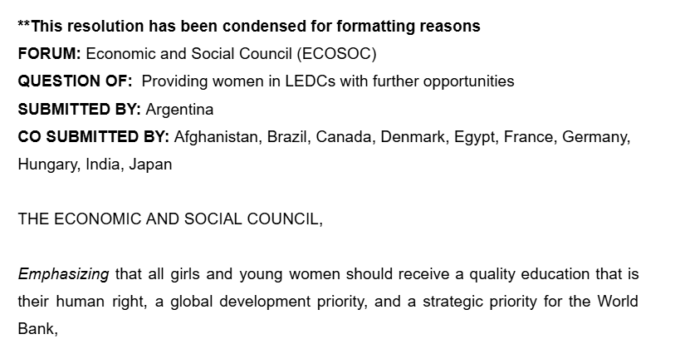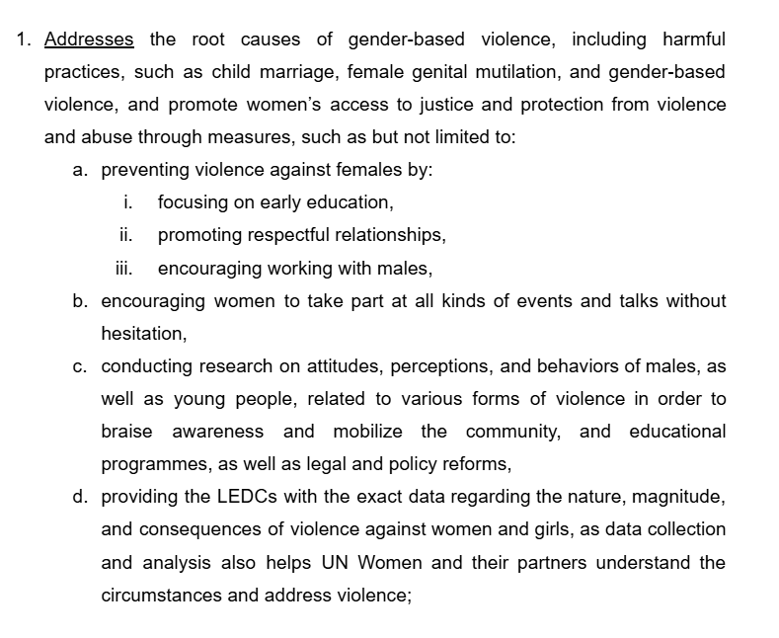
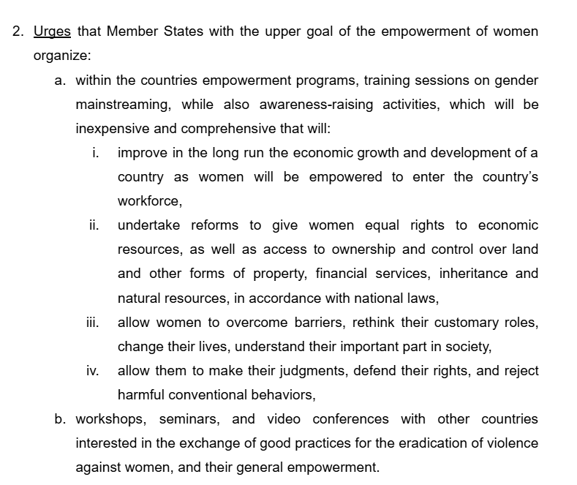

5.6 Lobbying Procedure
Lobbying is the period during which delegates negotiate, build alliances, and collectively draft the resolutions that the committee will subsequently debate. The quality of what emerges from lobbying determines the quality of debate.

5.6.1 Forming Lobbying Groups
Delegations whose national positions on the committee topic broadly converge will form lobbying groups. A dedicated shared Google Document will be set up by the Chairs for each group, and it is within this document that the draft resolution is to be collaboratively written. Delegates are encouraged to arrive at the conference having prepared draft clauses in advance.
Every delegate in the group must have a genuine opportunity to contribute their ideas before any clause is finalised. The Chairs will actively ensure that no single delegate dominates the drafting process at the expense of others.

5.6.2 Merging Resolutions
Where two or more lobbying groups have produced resolutions with compatible approaches to the same topic, the Chairs will actively encourage them to merge their documents into a single, stronger resolution.

5.6.3 The Main Submitter
Every resolution requires a Main Submitter: the delegation that formally presents the resolution to the committee, reads the operative clauses aloud at the outset of debate, and delivers the principal speech in favour. The selection of the Main Submitter must be a democratic and collegial decision of the lobbying group. It must not be determined by seniority or external pressures. If delegates are having a hard time selecting their main submitter, the Chairs can also help in facilitating a vote in that alliance.

5.6.4 The Approval Panel Process
Every resolution must pass through the Approval Panel before it may be debated. The sequence is as follows:

STEP 1: Resolution is drafted collaboratively in the shared Google Document during lobbying.
▼
STEP 2: Chairs review the document for formatting compliance, adherence to the UN Charter, original content, and appropriate language.
▼
STEP 3: Any required corrections are communicated to the Main Submitter by the Chair responsible for that alliance.
▼
STEP 4: The Chairs send the resolution to the approval panel.
▼
STEP 5: If approved, the resolution is placed in the queue for formal debate.
▼
STEP 6: If further corrections are required, the process returns to Step 3.

5.7 Plagiarism Policy
Plagiarism is the act of representing another person's or organisation's ideas, words, or written work as one's own, without proper attribution or sufficient original transformation.
The following constitute plagiarism in the context of resolution drafting at SCMUN:
- Copying clauses or significant portions of clauses directly from any existing UN document, or other published source.
- Paraphrasing source material so superficially that only the sequence of words or a small number of terms has been altered.
- Using Artificial Intelligence tools to generate full clauses or complete resolutions. AI may legitimately be used as a research and information-gathering tool; it may not be used to produce resolution text.
Self-plagiarism is permissible only if the source is acknowledged and substantial new and original material is contributed alongside it.

Chapter 6 CONFERENCE PREPARATION

6.1 Background Research
Delegates who arrive with a thorough understanding of their country's positions, the history of the issue, and the landscape of international opinion will participate with more confidence and depth.

6.2 Policy Statements and Opening Speeches
A policy statement is a short, formally structured speech (typically no longer than one minute) through which a delegate articulates their country's official position on of the committee's topics. It should include: the country's stance, its history on the issue, and the broad direction of the proposals it intends to pursue.
Policy statements serve several integral functions within the conference:
- They signal your country's position to other delegates, enabling prospective allies to identify you and approach you during lobbying.
- They establish your credibility.
A policy statement must be structured as a coherent formal speech. The Chair will cut a speaker off immediately if the one-minute limit is exceeded.
In SCMUN General Assembly committees, opening speeches may be scheduled at the commencement of committee work on each topic. All Ambassadors of delegations will be notified in advance of their obligation to speak. The structure of an effective policy statement is illustrated by the example below:

DELEGATION OF: Germany
FORUM: Human Rights Council (HRC)
QUESTION OF: Addressing the growing crisis of climate-induced displacement
Germany has long been committed to advancing international cooperation on humanitarian protection and sustainable development. As a leading supporter of multilateral climate initiatives and a key contributor to global refugee assistance programs, this delegation recognizes the urgent and complex challenges posed by climate-induced displacement.
Germany views with deep concern the absence of a clear and binding international framework to protect individuals displaced by climate-related factors, and calls upon all Member States to enhance coordination between humanitarian and climate institutions, strengthen legal protections for affected populations, and support the development of a comprehensive international instrument that ensures accountability and long-term solutions for climate refugees.
This delegation looks forward to constructive and solution-oriented debate, and to collaborating with all Member States in crafting a resolution that is both forward-thinking and grounded in actionable policy measures.

Chapter 7 SPEECHES AND POINTS OF INFORMATION

Active, substantive participation in debate is the most direct expression of a delegate's engagement with the committee's work. Delivering well-constructed speeches and raising incisive Points of Information are integral to the debate process.

7.1 Speech Template
The following template provides a reliable structural framework for a formal committee speech. Adapt it as necessary for the specific clause or argument you wish to address, while maintaining throughout the formal register and third-person convention that SCMUN proceedings require:

Honourable Chairs and fellow delegates,
We, the delegation of ________, stand firmly in favour of / against this resolution.
We draw the attention of this committee to Operative Clause ____, which addresses [briefly summarise the clause — do not read it verbatim from the page].
Our delegation wishes to make the following observations regarding this clause:
— This clause is significant because [explain its relevance to the core problem before this committee].
— It advances a solution to the issue by [explain the mechanism, approach, or commitment it establishes].
— Its importance to the broader international community lies in [explain the wider implications or precedent it sets].
— In terms of operational effectiveness, this clause [is / may not be] capable of achieving its objectives because [explain your assessment].
— With respect to practical universality, this clause [is / may not be] feasible for all Member States, particularly given [reference relevant considerations for LEDCs or MEDCs].
— Regarding implementation challenges, our delegation [anticipates / does not anticipate] obstacles of an [economic / political / cultural / logistical] nature, specifically [explain].
— The long-term effectiveness of this clause may be assessed through [propose a monitoring or evaluation mechanism].
In light of these considerations, the delegation of ________ calls upon all Member States to vote [in favour of / against] this resolution.
Thank you.

7.2 Critical Questions for Speech Writing
Before drafting a speech, a delegate should subject both the resolution and their country's position to genuine critical scrutiny. The questions below are designed to guide that process:
- Does this resolution address the structural root causes of the problem it seeks to resolve?
- How does this resolution affect my assigned country specifically? Are the implications broadly positive, broadly negative, or nuanced?
- Which clauses are aligned with my country's foreign policy and national interests?
- Are there gaps, ambiguities, or intentionally vague formulations in the resolution text that require clarification or amendment before the committee can responsibly vote?
- What are the long-term consequences of this resolution?
- How do the proposed measures account for the perspectives and needs of marginalised populations?
- Are there any unintended negative consequences that specific clauses could produce if implemented? How could these be mitigated?
- Does the resolution treat LEDCs and MEDCs equitably?

7.3 Points of Information: Categories and Examples
Points of Information (POIs) are the principal mechanism through which delegates engage directly and analytically with speakers during debate. The following categories and examples provide a practical guide:

7.3.1 General Clarification
- 'Could the honourable delegate explain the reasoning behind operative clause ____?'
- 'Does the delegation believe that this resolution, considered as a whole, addresses every dimension of the issue being debated?'

Inclusivity
- 'How does the delegation ensure that Less Economically Developed Countries would also have equitable benefits from the measures outlined in operative clause ____?'
- 'Has the delegation considered whether the measures in operative clause ____ are culturally appropriate across all Member States affected?'

7.3.3 Enforceability
- 'Could the delegate specify how the measures in operative clause ____ will be monitored, verified, and held accountable at the international level?'

7.3.4 Effectiveness
- 'How will the success or failure of operative clause ____ be monitored and measured following its implementation?'
- 'Does operative clause ____ address both the immediate short-term and the long-term consequences of the issue?'

7.3.5 Global Cooperation
- 'Is the delegation satisfied that this resolution promotes equitable cooperation among all Member State?'
- 'What specific role do Non-Governmental Organisations (NGOs) have in the implementation of operative clause ____?'

7.3.6 Ethical Considerations
- 'Does the delegation believe that this resolution provides adequate and enforceable protection for the most vulnerable groups affected by the issue?'

Appendix NOTE-PASSING GUIDELINES

Note-passing allows delegates to communicate with one another and with the Chairs during committee sessions without interrupting the proceedings at the podium. All notes must be written in English.
- The content of every note must be directly and genuinely relevant to the ongoing committee proceedings. Notes containing personal remarks, off-topic commentary, or content unrelated to the debate are out of order.
- Bullying, harassment, threats, offensive language, or inappropriate content of any kind in notes is a serious disciplinary matter. The Chairs and conference staff may read any note passed during a session. Any delegate found to have sent such a note will be referred to their advisor and to the conference Secretariat.
Note-passing is automatically suspended once voting procedures begin and may not resume until the vote has been formally concluded and the result announced.
- The Chairs may suspend note-passing at any point during the session if it is determined to be causing a disruption to proceedings.

